CIE 552 mini-project 2

Team name: Kimochi yamate

Ahmed Mahmoud Abd-Elmoniem 201800683

Hazem Muhammad Tarek 201800283

**Local feature matching**

**Introduction**

This project focuses on feature matching between two images. It consists of three main steps:

• Interest points detection: using Harris Corner Detector algorithm.

• Local feature description: Representing the features and regions around the location in the image as a vector called feature vector using Scale-Invariant feature transform (SIFT) technique.

• Feature matching: Matching features by calculating the distance between

features and find similarities by implementing the Nearest Neighbor Distance Ratio algorithm.

**Interest points detection algorithm**

* Blur the image using the gaussian filter.
* Calculate the gradient of the image using the following equation: $∇I_{0}{(x}_{i)}=(\frac{∂I_{0}}{∂x}$, $\frac{∂I_{0}}{∂y})x_{i}$*.*
* Calculate the following parameters:

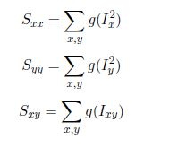

* Calculate the C matrix using the following equation:
$$C= S_{xx }o S_{yy }-s_{xy}^{2}-alpha*{(S_{xx }+S_{yy})}^{2}$$

* Select interest points based on a certain threshold.

**SIFT implementation algorithm**

* Represent the points in a 128-point vector.
* Blur the image using the gaussian filter.
* Calculate the gradient of the image using the following equation: $∇I_{0}{(x}_{i)}=(\frac{∂I_{0}}{∂x}$, $\frac{∂I_{0}}{∂y})x_{i}$*.*
* Calculate the magnitude and angle gradients using the following equations:
$$magnitude gradient= \sqrt{I_{x}^{2}+I_{y}^{2}}$$

$$Direction gradient=arctan⁡(I_{x},I_{y})$$

* Apply a gaussian filter on a 16x16 size window.
* Divide the 16x16 slots into 16 4x4 slots.
* On the edge of the 4x4 table, calculate the histogram with bins=8 for the 128-point vector at each interest point.
* Reshape the 16x8 matrix into a 128-point vector.
* Normalize the vector.
* Clamp all vector values > 0.2 to 0.2.

**Feature matching**

* Compare the points using the nearest neighbor distance ratio.
* Calculate the Euclidean distances using the following equation:

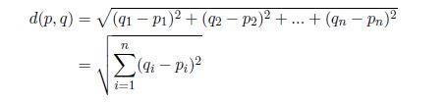

* If the 0.8 distance is equal the 2nd distance, then the value vector with minimum distance is calculated as a match between two keys points.

**Results**

**Notre Dame**

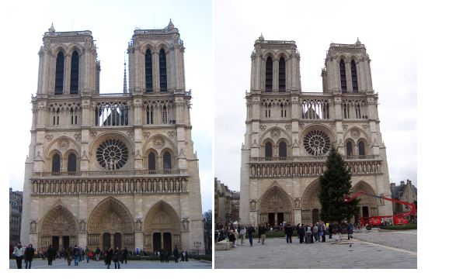

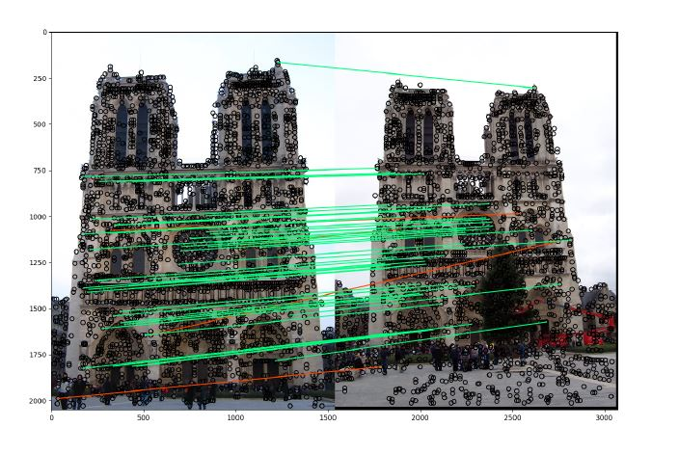

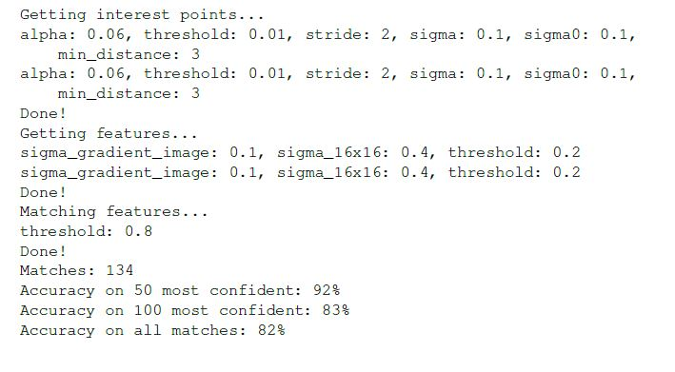

**Mount Rushmore**

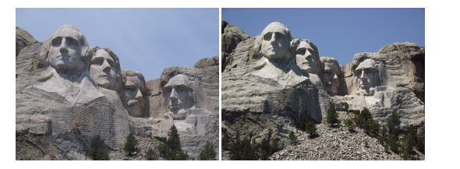

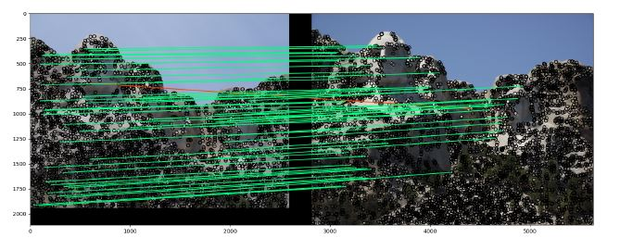

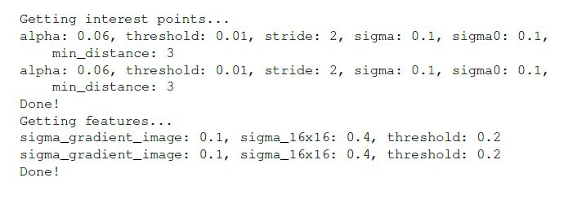

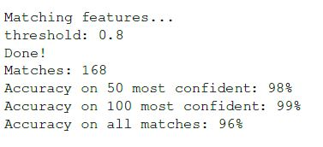

**Episcopal Gaudi**

